Central Susquehanna Transition Alliance
Names of Council:
Columbia Montour Transition Council
Northumberland Transition Council
Union Snyder Transition Council

Counties Served: Columbia, Montour, Northumberland, Union, & Snyder Counties

School Districts Served:
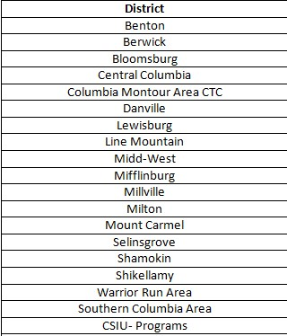

Meeting Dates Varies by council typically monthly or bimonthly with a comprehensive meeting of all three councils at the end of the year.:

Meeting Location:
Columbia Montour AVTS (Columbia Montour Council)
Northumberland County Human Services Building (Northumberland Council)
Selinsgrove Area High School (Union Snyder Council)

Contact: Misty Harris
(570)556-8800
mharris@csiu.org

